Annex 1 CMP Waste order form (NOT CRUISE SHIPS) 2021 - 24 hours in advance of arrival
E-mail portoffice@cmport.com

Name of ship: | Berth no: | Project no. completed by CMP: ______________
IMO number: Last Port and Country: Ship Agent:
Ship arrival Date: | Arrival Time: | Departure Date: | Time:
Waste delivery Date: Delivery Time: |  | Name/ Signature:

CMP waste  management  plan | Type of waste | Amount for discharge | Comments | Waste operators
 | MARPOL Annex 1 – Oil (m³)
Section 5. | Oily residues (Sludge)
Section 6.  Complete Annex 3 | Oily tank washings
MARPOL Annex VI – Air pollution (m³) Comments
Comments to CMP
Section 7.  Complete Annex 3 | Exhaust gas-cleaning residues - Scrubber (fluid)  AEP scrubber effluents (fluid) |  | PH value:  (PH 5,5 – 8,5)  (PH 6,5 - 9)
MARPOL Annex IV – Sewage (m³) Comments

Section 8.  Complete Annex 4 | Sewage (Black water and Grey water)  Treated Waste Water |  |  | 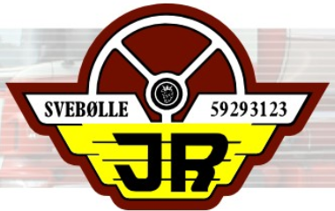
MARPOL Annex V – Garbage (m³) Comments

)

Section 9.  and  Section 10. | SMALL WASTE and FOOD WASTE for incineration -  Clear plastic bags - Maximum size 100x50x50 cm
 | WOODEN PALLETS for recycling  Put next to the red container - Will be picked up by CMP |  |  | 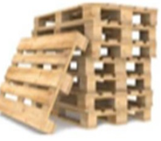
 | LARGE WASTE for pre-sorting - On pallets, in boxes or big bags
 | Clean PLASTIC - Sorted in rigid, soft and PET bottles
 | Dry and clean CARDBOARD - Bailed on pallets
 | GLASS for recycling (NO crockery or mirror) - In big bags
 | CROCKERY for landfill (NO glass) - In big bags
 | IRON, METAL, ALUMINIUM, TIN CANS - On pallets or in boxes
MOORING LINES, STEEL WIRE - On pallets
FURNITURE, CARPETS, MATTRESSES - Please specify
 | OTHER GARBAGE - Please specify
 | Kg Comments/ UN Number
 | BATTERIES, ACCUMULATOR - In plastic bags or cardboard boxes |  |  | *CMP own reception on Oceankaj
 | ELECTRONICS - In cardboard boxes
 | LIGHT BULPS, FLUORESCENT LAMPS - In boxes
 | PAINT, THINNERS, CHEMICALS - With correct labels on each
 | MEDICALS, BIO HAZARDOUS - In plastic bags or cardboard boxes
 | OILY SLUDGE in drums, OILY RAGS, OIL FILTERS etc.
 | COOKING OIL
 | OTHER HAZARDOUS waste - Please specify
Section 11. | INCINERATOR ASH - In liftable sealed big bags
 | SCRUBBER (solid) - In UN drums
 | BLACK WATER/ GREY WATER residues (solid) - In UN drums
 | FIRE EXTINGUISHER - Gas art requirement !
EMERGENCY PYROTECHNICS/ MOB SMOKE FLOATS
-Safety data sheet requirement !

